**BR_Translation – Translation Services**

Robin Lamacraft 2017-04-20

**SCOPE**

This module must be used anywhere text strings may have a Translation that needs to be stored or retrieved. These text strings may be stored in database tables according to their length. Text strings may be plain or encoded. Some collections of values have extra relationships that need to be managed as part of the translated string storage.

Translated strings are classified as follows:

1. The expected maximum length of a particular entry type
2. The place of generation or use of translated values
3. The special interactions between values within the same type of data entry.

**Subdivision by expected Maximum Length**

2 Strings lengths are used:

* Normal max. 8000 characters but only uses actual string length as VARCHAR() with MAX_VALUE set to 8000)
* Huge max. 2Gb characters as a CLOB (character BLOB).

**Subdivision by place of generation or use**

* Associated with the GUI
  + GUI Labels and options
  + Reminders and Help
  + Error and Warning Messages.
* Associated with user data and auxiliary definitions
  + Auxiliary Definitions (Tags, etc)
  + Name Element entry
  + Output Templates and Sentences
  + Memos with embedded Citations.

NOTE: The text below is divided into 2 parts: GUI related and Data-related.

**GUI SECTION**

**GUI-RELATED ACTIONS**

1. To define or modify a GUI Translation Dictionary entry: Create, Edit, Save and Retrieve
2. To define or modify a language-specific value: Create, Edit, Save and Retrieve.

NOTES: Some entries like Error and Warning Messages are encoded for value substitution. The size of these tables is only influenced by the number of Application Languages installed.

**GUI-USED BY**

Any GUI module.

**GUI-DATA CONTROLLED BY THIS MODULE**

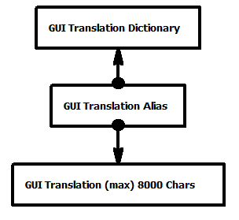

1. **GuiTransDict** Table: One record per Gui Element that has a translation

|  |  |  |
| --- | --- | --- |
| **SQL FIELD NAME** | **SQL FIELD TYPE** | **NOTES** |
| **HRE COMMON FIELDS FIRST HRE_ID is GuiTransDict_ID** | | |
| GUI_ELMT_ID | INT8 NOT NULL | HRE ID for the GUI element that this translation applies to |
| ELMT TYPE_ID | INT8 NOT NULL | HRE Gui Element Type ID |
| LIST_COUNT | INT4 | Default 1, number in selection list |
| STORE_TYPE_ID | INT4 | HRE String Storage Type ID |
| ENCODE_ID | INT8 NOT NULL | HRE Encoding Type ID |

The PRIMARY INDEX of this table is the HRE_ID. (GuiTransDict)

1. **GuiTransAlias**Table: One record for each Dictionary Link to a Translation

|  |  |  |  |
| --- | --- | --- | --- |
| **SQL_FIELD NAME** | **SQL_FIELD TYPE** | | **NOTES** |
| **HRE COMMON FIELDS FIRST HRE_ID is GuiTransAlias_ID** | | | |
| PARENT_ID | INT8 NOT NULL | Parent HRE GuiTransDict ID | |
| LANG_ID | INT8 NOT NULL | HRE Language ID | |
| TRANS_ID | INT8 NOT NULL | The HRE Translation ID | |

The PRIMARY INDEX of this table is the HRE_ID. (GuiTransAlias)

1. **GuiTrans** Table: One record for each Translation (max. 8000 characters)

|  |  |  |  |
| --- | --- | --- | --- |
| **SQL_FIELD NAME** | **SQL_FIELD TYPE** | | **NOTES** |
| **HRE COMMON FIELDS FIRST HRE_ID is GuiTrans_ID** | | | |
| PARENT_ID | INT8 NOT NULL | Parent HRE GuiTransDict ID | |
| LANG_ID | INT8 NOT NULL | HRE Language ID | |
| ITEM_NUM | INT4 | The item number for a selection list | |
| TRANS | VARCHAR() | Translation for this GuiElement in this language | |

The PRIMARY INDEX of this table is the HRE_ID. (GuiTrans)

**USER DATA SECTION**

**USER DATA RELATED ACTIONS**

1. To define or modify a User Data Translation Dictionary entry: Create, Edit, Save and Retrieve
2. To define or modify a language-specific value: Create, Edit, Save and Retrieve.

NOTES: Some entries like Sentences, Output Template are encoded for value substitution. The size of these tables is not only influenced by the number of User Languages installed, but they grow as more data is entered. To overcome querying very large tables some large tables are split according to their relationship to some data types, e.g. Person Name Elements and Location Name Elements and Source Name Elements are held in their own tables, but serviced by this module. As more research types are installed it is likely that these will imply additional name element tables.

**USER DATA-USED BY**

Any GUI module or Substitution operation.

**USER-DATA CONTROLLED BY THIS MODULE**

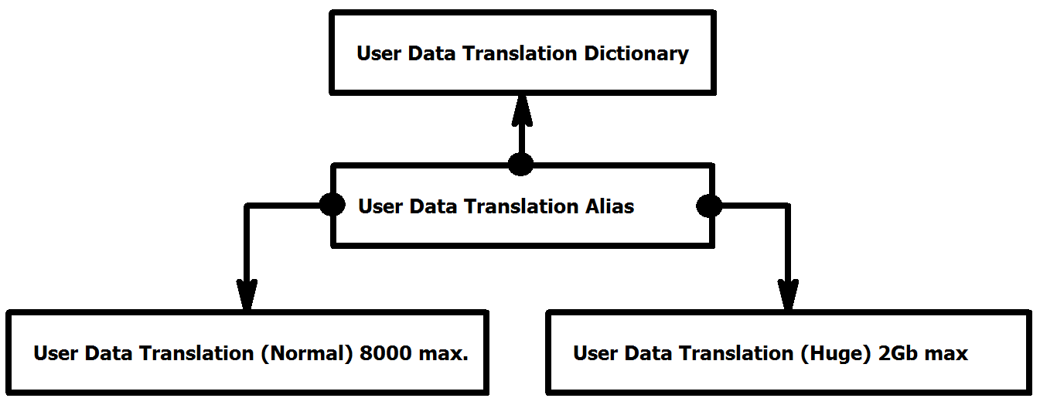

1. **UserDataTransDict** Table: One record per translatable field

|  |  |  |
| --- | --- | --- |
| **SQL FIELD NAME** | **SQL FIELD TYPE** | **NOTES** |
| **HRE COMMON FIELDS FIRST HRE_ID is GuiTransDict_ID** | | |
| FIELD_REF_ID | INT8 NOT NULL | HRE ID for the Field reference to which this translation applies |
| FIELD_TYPE_ID | INT8 NOT NULL | HRE Field Type ID |
| LIST_COUNT | INT4 | Default 1, number in selection list |
| STORE_TYPE_ID | INT4 | HRE String Storage Type ID |
| ENCODE_ID | INT8 NOT NULL | HRE Encoding Type ID |

The PRIMARY INDEX of this table is the HRE_ID. (GuiTransDict)

1. **UserDataTransAlias**Table: One record for each Dictionary Link to a Translation

|  |  |  |  |
| --- | --- | --- | --- |
| **SQL_FIELD NAME** | **SQL_FIELD TYPE** | | **NOTES** |
| **HRE COMMON FIELDS FIRST HRE_ID is UserDataTransAlias_ID** | | | |
| PARENT_ID | INT8 NOT NULL | Parent HRE UserDataTransDict ID | |
| LANG_ID | INT8 NOT NULL | HRE Language ID | |
| TRANS_ID | INT8 NOT NULL | The HRE Translation ID | |

The PRIMARY INDEX of this table is the HRE_ID. (UserDataTransAlias)

1. **UserDataTrans** Table: One record for each Translation (Normal max. 8000 characters)

|  |  |  |  |
| --- | --- | --- | --- |
| **SQL_FIELD NAME** | **SQL_FIELD TYPE** | | **NOTES** |
| **HRE COMMON FIELDS FIRST HRE_ID is GuiTrans_ID** | | | |
| PARENT_ID | INT8 NOT NULL | Parent HRE UserDataTransDict ID | |
| LANG_ID | INT8 NOT NULL | HRE Language ID | |
| ITEM_NUM | INT4 | The item number for a selection list | |
| TRANS | VARCHAR() | Translation for this Field Value in this language | |

The PRIMARY INDEX of this table is the HRE_ID. (UserDataTrans)

1. **UserDataTransH** Table: One record for each Translation (Huge max. TRANS 2Gb characters)

|  |  |  |  |
| --- | --- | --- | --- |
| **SQL_FIELD NAME** | **SQL_FIELD TYPE** | | **NOTES** |
| **HRE COMMON FIELDS FIRST HRE_ID is GuiTransH_ID** | | | |
| PARENT_ID | INT8 NOT NULL | Parent HRE UserDataTransDict ID | |
| LANG_ID | INT8 NOT NULL | HRE Language ID | |
| ITEM_NUM | INT4 | The item number for a selection list | |
| TRANS | CLOB | Translation for this Field Value in this language | |

The PRIMARY INDEX of this table is the HRE_ID. (UserDataTransH)

**GENERIC NAME STYLE RELATED TRANSLATIONS**

Name style related translations have additional properties as values may be ordered in a hierarchical sequence. There may be differences according the type of object that is being named. The same text value used for different name element fields cannot be considered equivalent. For example the word “Washington” as an element of a Location name can be used with different consequences for several levels of Name Element use. This is also important when providing data entry completion hints.

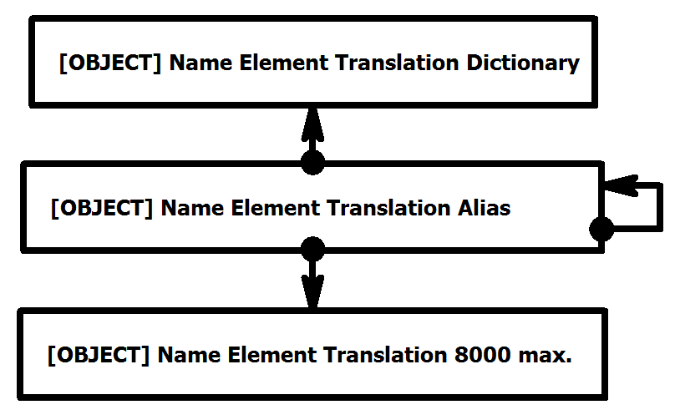

1. **[OBJECT]NameElmtDict** Table: One record for each Name Element entry

|  |  |  |
| --- | --- | --- |
| **SQL FIELD NAME** | **SQL FIELD TYPE** | **NOTES** |
| **HRE COMMON FIELDS FIRST HRE_ID is [OBJECT]NameElmtDict_ID** | | |
| FIELD_REF_ID | INT8 NOT NULL | HRE ID for the Field reference to which this translation applies |
| NAME_STYLE_ID | INT8 NOT NULL | HRE ID of the Name Style for this Name Element |
| NAME_ELEM_ID | INT8 NOT NULL | HRE ID of the Name for this Name Element |
| FIELD_TYPE_ID | INT8 NOT NULL | HRE Field Type ID |
| ENCODE_ID | INT8 NOT NULL | HRE Encoding Type ID |

The PRIMARY INDEX of this table is the HRE_ID. ([OBJECT]NameElmtDict)

1. **[OBJECT]NameElmtAlias**Table: One record for each Dictionary Link to a Translation

|  |  |  |  |
| --- | --- | --- | --- |
| **SQL_FIELD NAME** | **SQL_FIELD TYPE** | | **NOTES** |
| **HRE COMMON FIELDS FIRST HRE_ID is [OBJECT]NameElmtAlias_ID** | | | |
| PARENT_ID | INT8 NOT NULL | Parent HRE [OBJECT]NameElmtDictDict ID | |
| LANG_ID | INT8 NOT NULL | HRE Language ID | |
| TRANS_ID | INT8 NOT NULL | The HRE [OBJECT]NameElmtTrans ID | |
| NEXT_ALIAS_ID | INT8 NOT NULL | The HRE [OBJECT]NameElmtAlias ID (used for hierarchically related Name Elements] | |

The PRIMARY INDEX of this table is the HRE_ID. ([OBJECT]NameElmtAlias)

1. **[OBJECT]NameElmtTrans**Table: One record for each Translation (max. 200 characters)

|  |  |  |  |
| --- | --- | --- | --- |
| **SQL_FIELD NAME** | **SQL_FIELD TYPE** | | **NOTES** |
| **HRE COMMON FIELDS FIRST HRE_ID is [OBJECT]NameElmtTrans_ID** | | | |
| PARENT_ID | INT8 NOT NULL | Parent HRE [OBJECT]NameElmtAlias ID | |
| LANG_ID | INT8 NOT NULL | HRE Language ID | |
| ITEM_NUM | INT4 | The item number for a selection list | |
| TRANS | VARCHAR() | Translation for this Field Value in this language | |

The PRIMARY INDEX of this table is the HRE_ID. ([OBJECT]NameElmtTrans)

**PERSON NAME STYLE RELATED TRANSLATION TABLES**

1. **PersonNameElmtDict**
2. **PersonNameElmtAlias**
3. **PersonNameElmtTrans**Table

**LOCATION NAME STYLE RELATED TRANSLATION TABLES**

1. **PersonNameElmtTrans**
2. **PersonNameElmtAlias**
3. **PersonNameElmtTran**s

**SOURCE NAME STYLE RELATED TRANSLATION TABLES**

1. **SourceNameElmtDict**
2. **SourceNameElmtAlias**
3. **SourceNameElmtTrans**

**REQUIRED SERVICES**

1. BR_EntityLink
2. BR_Field
3. BR GuiElement.

**WARNING CONDITIONS**

1. Need details of the condition that raised the warning, example message and possible next steps.

**ERROR CONDITIONS**

1. Need to record the condition that raised the error, example message and possible next steps.